­­­Bitmask DP

Bitmask DP: dynamic programming but one of the dimensions is bitmask

the bitmask usually represents a state over $n$ 0-1 things, or a subset of $n$ things

01010 -> 2nd and 4th element exist

Usually something like this:

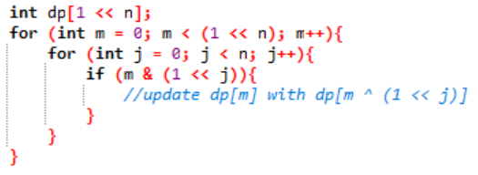or this:

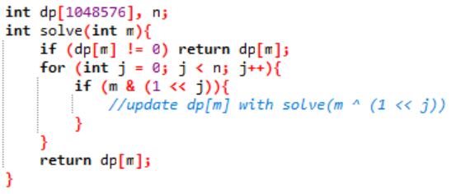

Note that this is not a fixed format, you can add dimensions and change the transition in various ways, so you have to be familiar with bitwise operators.

Job assignment

Given a cost matrix where $c_{i, j}$ is the amount of money you need to pay to hire worker $i$ for the $j^{th}$ job, assign each $n$ workers to distinct jobs to minimize amount of money.

if $n≤10$, can do next permutation

constraint: $n≤20$

bitmask DP!

$$dp\left[i\right]\left[mask\right]=minimum money to assign first i workers to subset of jobs in mask$$

$$dp\left[i\right]\left[mask\right]=\min{dp\left[i-1\right]\left[mask⊕2^{j}\right]} \left(j^{th} bit in mask is 1\right)$$

dp[3][01011] = min(dp[2][00011], dp[2][01001], dp[2][01010])

Existence of Hamiltonian path

$$dp\left[mask\right]\left[i\right]≔whether a Hamiltonian path exist over subset mask and end in node i$$

transition:

$$dp\left[mask\right]\left[i\right]=\bigvee_{j^{th} bit in mask = 1 and \left(j, i\right) ∈ E}{dp\left[mask⊗2^{i}\right]\left[j\right]}$$

base case: $dp\left[mask\right]\left[i\right]=1 if mask=2^{i}$

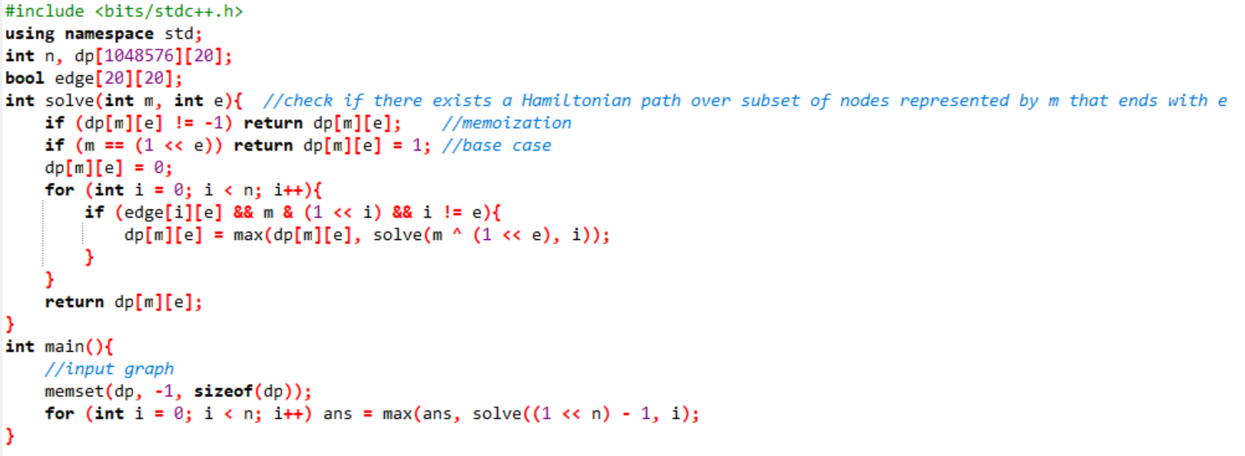time complexity: $O\left(2^{n}n^{2}\right)$

Can we do faster??? ??

Actually yes!! State compression!

$$bool dp\left[mask\right]\left[0 \sim n-1\right]→int dp[mask]$$

$i^{th}$ bit in the new $dp[mask]$ is $dp\left[mask\right][i]$

so the $dp[mask]$ itself is now a mask, where the $i^{th}$ bit represent if there exist a Hamiltonian path over $mask$ that ends in $i$. Don’t get them confused!

But how about the transition???

Another big brain technique: representing the graph with masks

bool adjacency matrix [n][n] 🡪 int adjacency matrix but masks [n]

Now with these tools provided, try to think of the transition yourself!

Transition:

$$dp\left[mask\right]=\sum_{i=0}^{n-1}{2^{i}×(dp\left[mask⊗2^{i}\right] \& adj\left[i\right]>0)}$$

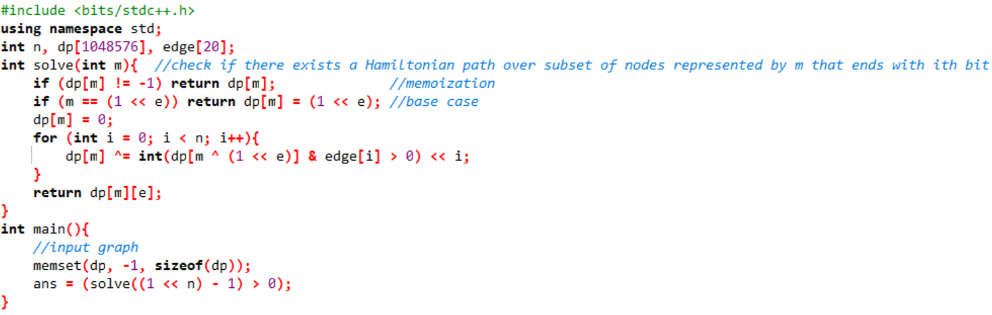time: $O\left(2^{n}n\right)$ wow!

Sum over subset DP

Given a fixed array of $2^{n}$ integers, calculate for all $x$ the sum of all $a[i]$ such that $i$ is an subset of $x$.

f(10100) = a[00000]+a[00100]+a[10000]+a[10100]

just iterate submasks of all masks: $O\left(4^{n}\right)$?

Actually no!

for each bit, it can be: 0 in mask and 0 in submask, 1 in mask and 0 in submask, or 1 in mask and 1 in submask

Therefore it is $O(3^{n})$. This knowledge is useful when you come up with some transition formula that involves iterating all the submask of all masks.

However, we can do better!

Flaw: $a[i]$ is visited by $2^{n-popcount\left(i\right)}$ masks

Let $dp\left[m\right]=sum of a\left[x\right] for all submask x of mask m$.

Let $dp\left[m\right]\left[i\right]=sum of a\left[x\right] for all subset x of m that may differ from m only in the first i bits$

or $dp\left[m\right]\left[i\right]=all x such that m\&x=x and m⊕x<2^{i}$

For example, dp[101] (101, 100, 001, 000) becomes dp[**10**1][1] (**10**1, **10**0), dp[**1**01][2] (**1**01, **1**00) and dp[101][3] (101, 100, 001, 000) (bold: bits that cannot differ)

Now we can set up a recurrence relation!

If the ith bit is 0 the submasks cannot have a 1 at the ith bit, $S\left[m\right]\left[i\right]=S\left[m\right][i-1]$.

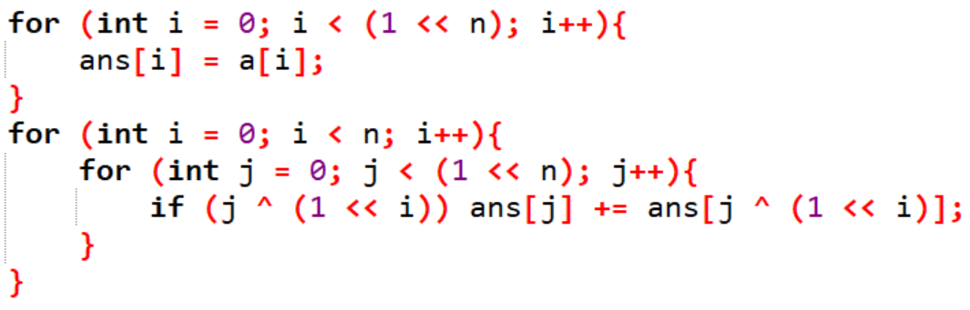Else, there are two choices: one with 1 at the ith bit ($S\left[m\right][i-1]$) and one with 0 at the ith bit ($S\left[m⊕2^{i}\right]\left[i-1\right]$).

$$S\left[m\right]\left[i\right]=\left\{\begin{aligned}S\left[m\right]\left[i-1\right] i^{th} bit 0 \\ S\left[m\right]\left[i-1\right]∪S\left[m⊕2^{i}\right]\left[i-1\right] i^{th} bit 1\end{aligned}\right.$$

^efficient implementation that reuse the array, it works because j ^ (1 << i) is always smaller than j, which means the answer to that state (ans[j ^ (1 << i] == dp[j ^ (1 << i)][i + 1]) is already calculated when updating the current one (from dp[j][i] to dp[j][i + 1])

This technique can be used to do M1830 lazy tutor

find other bitmask DP problems in dp tag